**Task 3- Event Management System using PostgreSQL.**

A. Retrieving All events

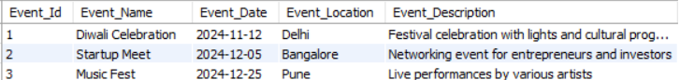

B. Retrieving list of attendees for a specific event

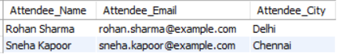

C. Revenue from all events  
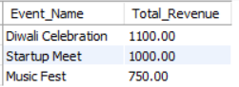

D. Total Attendance

